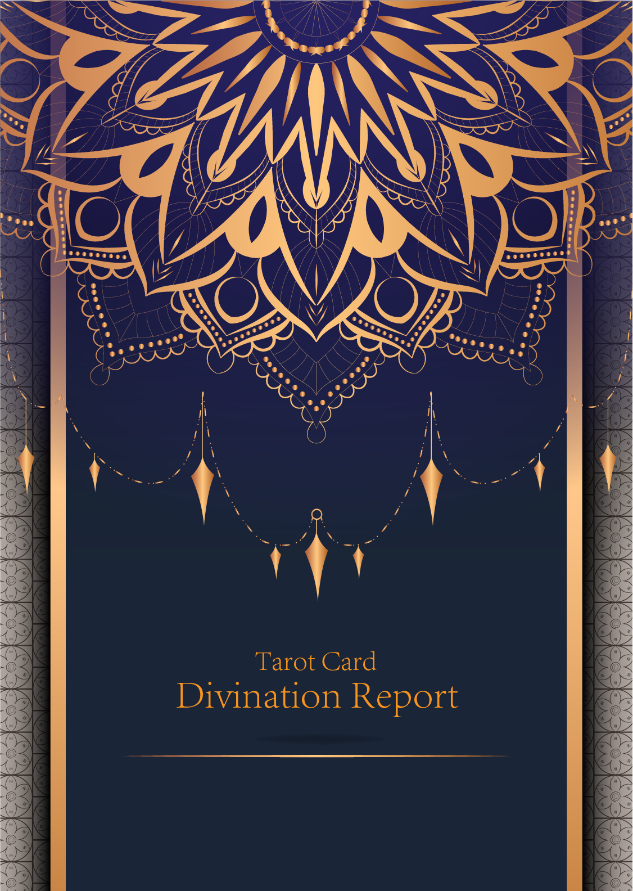

|  |
| --- |
| February 23, 2024 |

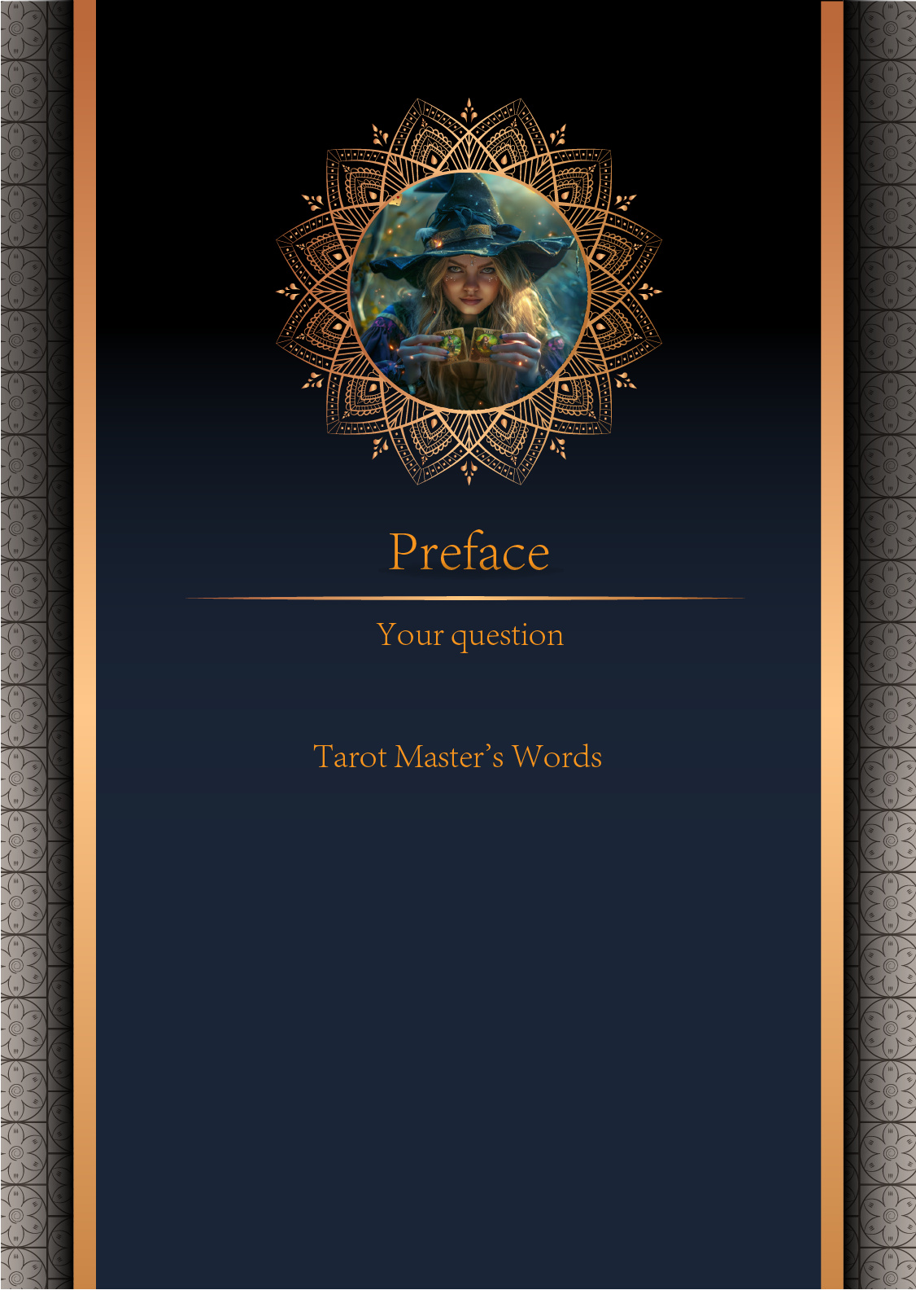

|  |
| --- |
| 我什么时候能结婚 |

|  |
| --- |
| Before we begin the interpretation, I would like to explain some important points to you. Tarot cards are not tools for predicting the future, but rather tools for guiding us to delve deeper into various situations in life. Therefore, when receiving the reading, please maintain an open mindset and trust your intuition. Our goal is to provide you with inspiration and guidance through the guidance of the tarot cards, helping you better deal with challenges and decisions in life. Alright, you can start reading now! |

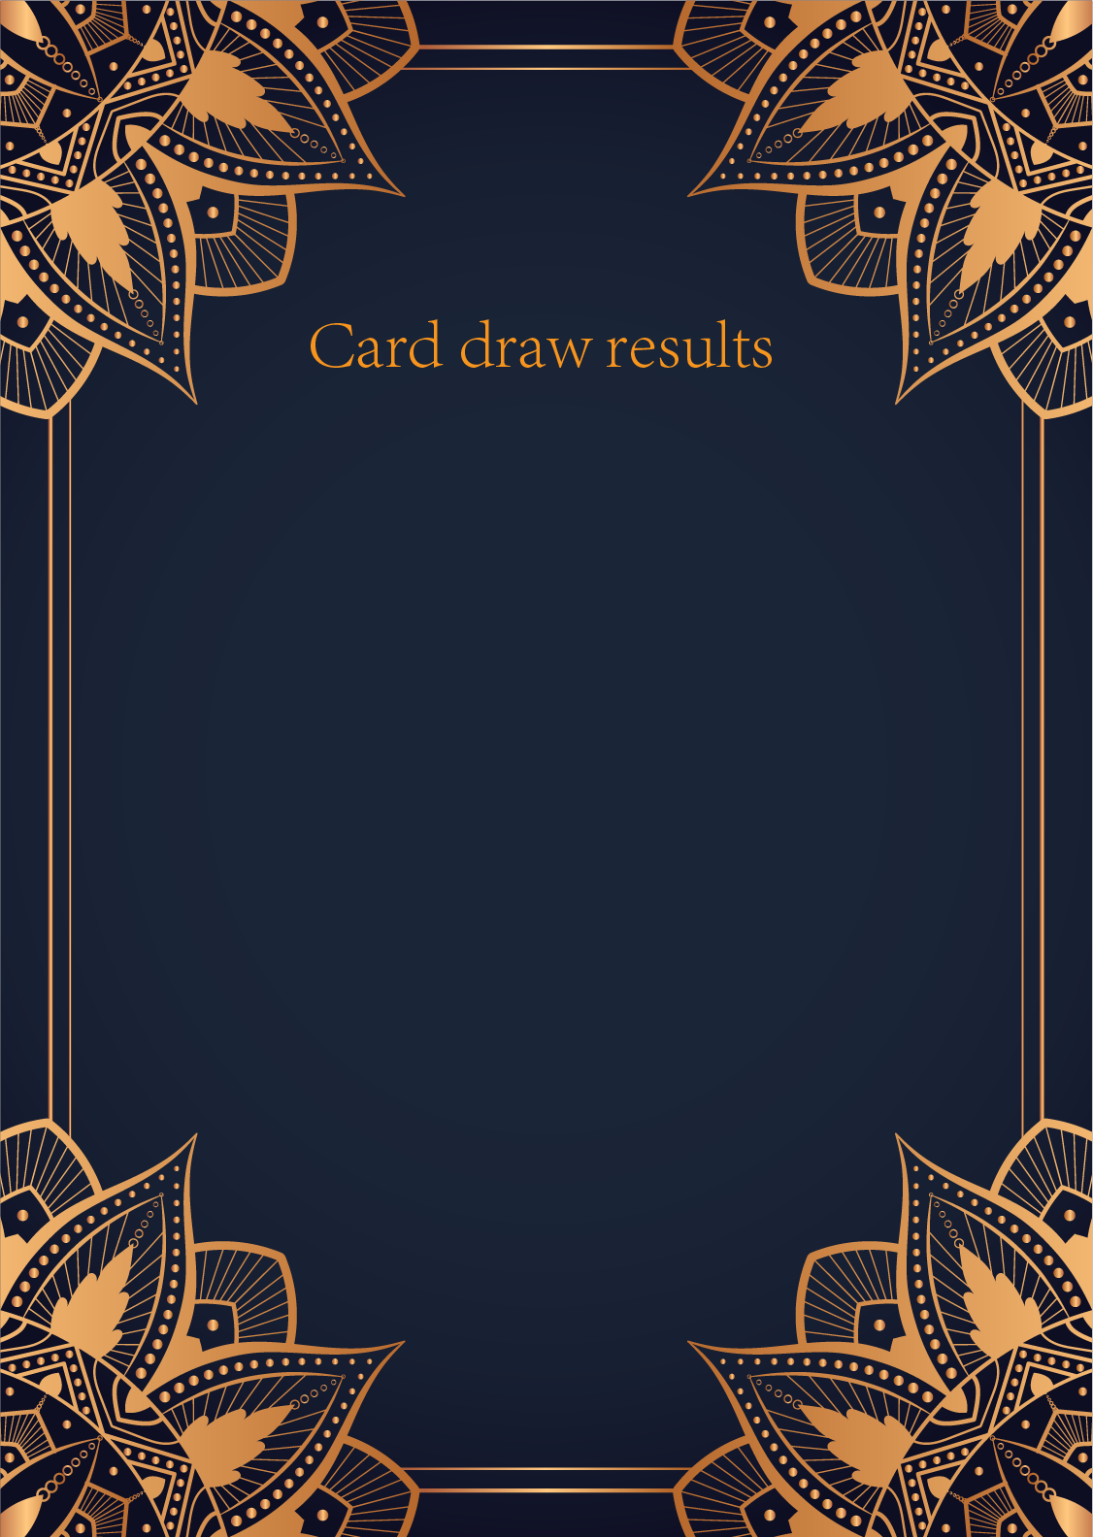

|  |
| --- |
| CardⅠ The Sun |
|  |
| The Sun card presents an feeling of optimism and fulfillment. This card represents the dawn which follows the darkest of nights. The Sun is the source of all the life on our planet, and it represents life energy itself. There is a child depicted in the card, playing joyfully in the foreground. A symbol of our innocence, it represents the happiness that occurs when you are in alignment with your true self. The child is naked, meaning that he has absolutely nothing to hide. The card also depicts the childhood innocence and absolute purity. This is particularly emphasized through the white horse upon which the child is riding. The horse here is also a symbol of strength and nobility. |

|  |
| --- |
| CardⅡ The Moon |
|  |
| When we encounter the Moon, we see a path that leads off into the distance. On either side of the path stand a wolf and a dog, representing our animalistic nature - one is civilized, and the other wild and feral. There is a crawfish that is crawling out of the pond from which the path stems from. In the distance, we can see two towers flanking the central path, once again alluding to the doubles visible in this card. Everything in this card seems to echo the other, as if to allude to two possibilities. When we walk down the path, we walk the fine line between conscious and unconscious, between the tamed side of civilization of the dog, and the forces of nature represented by the wolf. |

|  |
| --- |
| CardⅢ The Star |
|  |
| The Star card shows a woman kneeling at the edge of a small pond. She is holding two containers of water. One container pours the water out to the dry land, as if to to nourish it and ensure its fertility. The lush green land around her seems to say that it is working. One foot is inside the water which shows the spiritual abilities and inner strength of the woman. The other foot on the ground shows her practical abilities and strengths. Behind her, there is a large central star surrounded by seven small stars which represent the chakras. There is bird standing at a tree branch which represents the holy ibis of thought. The Star's astrological correspondent is Aquarius. |

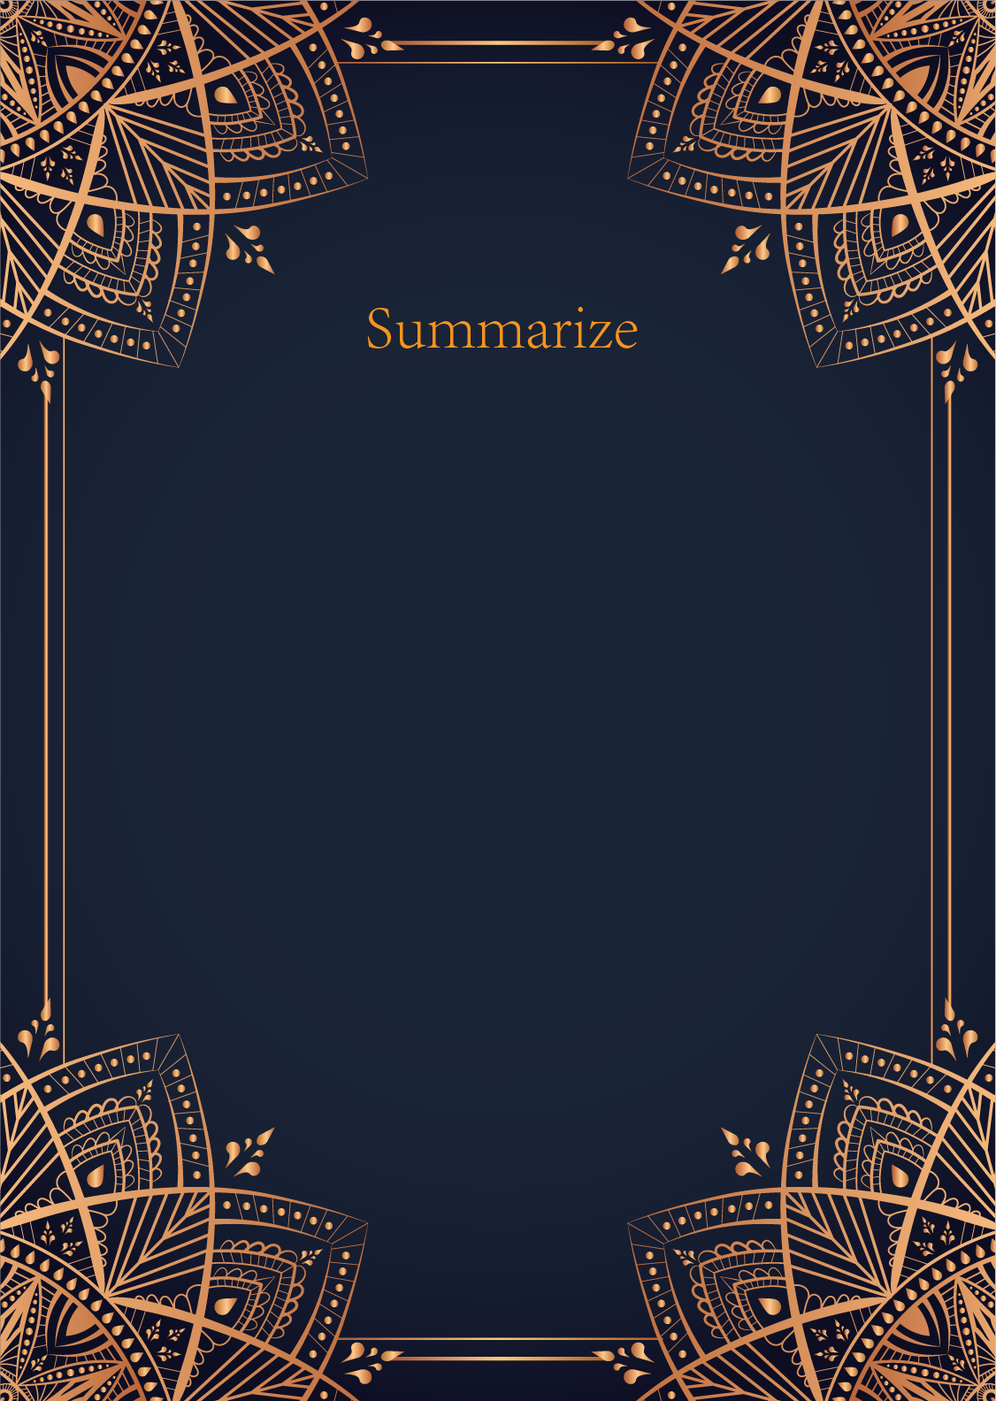

|  |
| --- |
| Ah, dear seeker, the cards have revealed a powerful message regarding your question about marriage. The Sun, the Moon, and the Star cards are symbols of illumination, intuition, and guidance. Let us delve into the mysteries they hold for you.   The Sun card shines brightly upon your path, indicating a time of joy, clarity, and fulfillment in your romantic endeavors. This card heralds a period of harmony and positivity in your relationships, suggesting that the energy surrounding you is vibrant and full of potential for love and commitment.   The Moon card whispers of intuition, dreams, and secrets. It urges you to trust your inner voice and explore your deepest desires when it comes to matters of the heart. This card also warns of illusions and hidden emotions that may cloud your judgment. Take time to reflect on your true feelings and intentions regarding marriage.   The Star card, with its serene and hopeful presence, signifies inspiration, healing, and guidance from above. It symbolizes a sense of faith and optimism in the future, especially in matters of love and relationships. The Star card encourages you to believe in the power of destiny and the alignment of the universe in shaping your romantic journey.  May these insights from the cards illuminate your path towards marriage. Remember, timing is often a reflection of our inner growth and readiness for such a significant commitment. Trust in the divine timing of the universe, and let love guide you towards the union you seek. Embrace the blessings of the Sun, the mysteries of the Moon, and the guidance of the Star as you embark on this sacred journey. Blessings upon you, dear seeker, as you navigate the beautiful path towards marriage. |

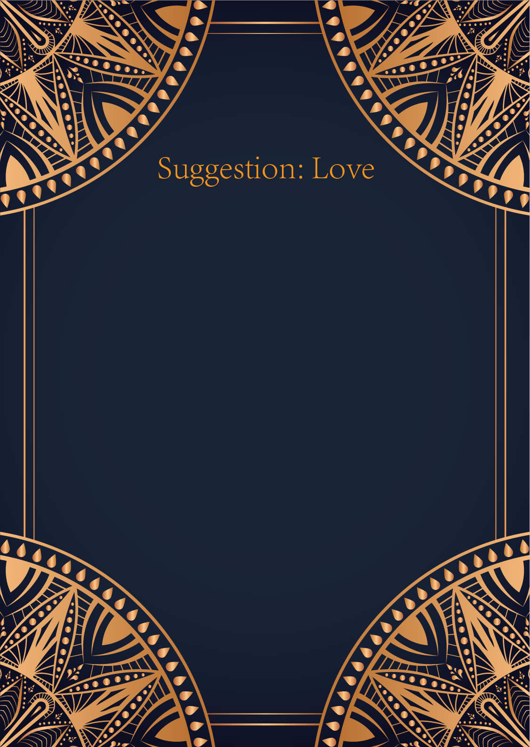

|  |
| --- |
| Ah, the Sun, the Moon, and the Star - a powerful combination indeed. These cards speak of illumination, intuition, and guidance in matters of the heart. Let us delve into the mystic realm of love and offer you some insights and advice.   The Sun card shines brightly upon your path, revealing joy, positivity, and success in your romantic endeavors. It signifies a new beginning filled with warmth and happiness. Embrace this energy and allow it to light up your heart, infusing your relationships with passion and vitality.   The Moon card, with its mysterious aura, urges you to trust your intuition and explore the depths of your emotions. It symbolizes the unseen forces at play in matters of love and reminds you to listen to your inner wisdom. Pay attention to your dreams and subconscious urges, as they may hold valuable insights into your relationships.   The Star card aligns with hope, inspiration, and renewal in matters of the heart. It encourages you to have faith in the universe and believe in the power of love to guide you towards your true desires. Allow yourself to dream big and envision the kind of love that fills your soul with light and fulfillment.   Together, these cards form a harmonious triad of love and guidance. They advise you to bask in the warmth of new beginnings, trust your instincts, and have faith in the universe's plan for your heart's journey. Remember to stay true to yourself, communicate openly and honestly with your partner, and nurture the love that flows between you.   In conclusion, let the radiant energy of the Sun, the mystical wisdom of the Moon, and the hopeful inspiration of the Star be your guide in matters of love. Embrace the magic of the universe and allow your heart to lead you towards a deep and fulfilling connection. Trust in the whispers of your soul and let love illuminate your path. Blessings be upon you, dear seeker of love. |

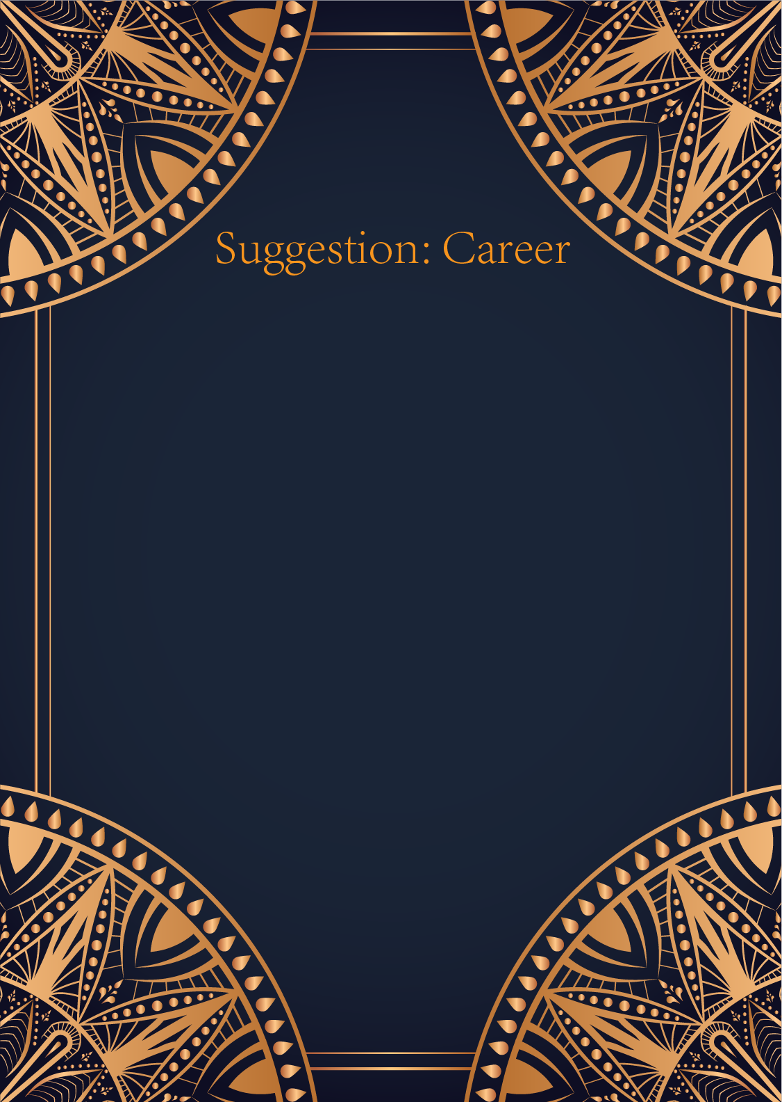

|  |
| --- |
| Ah, the Sun, the Moon, and the Star -- a powerful combination of cards that speaks volumes about your career path, my dear seeker. The Sun symbolizes success, achievement, and abundance in your professional endeavors. It urges you to embrace your talents and skills wholeheartedly, allowing them to shine brightly in the world. This card encourages you to step into the limelight and take on leadership roles with confidence and positivity. Trust in your abilities to overcome challenges and bask in the glory of your accomplishments, for the Universe is truly shining upon you.   The Moon, on the other hand, brings a deeper, intuitive aspect to your career journey. It signifies creativity, intuition, and the exploration of the subconscious mind. This card suggests that you may encounter periods of uncertainty or confusion in your work life, where things may not always be as they seem. Embrace the unknown and trust your inner guidance to navigate through the shadows. Allow your intuition to guide you towards opportunities that may not be immediately clear, for they may hold the key to unlocking your full potential.   And finally, we come to the Star -- a card of hope, inspiration, and serenity. It represents a sense of purpose and direction in your professional endeavors, guiding you towards your true calling. The Star encourages you to set high aspirations for yourself and to believe in the magic of the universe to manifest your dreams into reality. Trust that you are on the right path and that the cosmos are aligning in your favor. Embrace your unique gifts and share them with the world, for you are destined for greatness.   In conclusion, dear seeker, these three cards come together to paint a beautiful tapestry of your career journey. Embrace the success and abundance that the Sun brings, trust in your intuition and creativity as guided by the Moon, and hold onto hope and inspiration in alignment with the Star. Remember, you are a shining star in the vast universe of possibilities, and your career path is filled with endless potential. Trust in yourself, follow your intuition, and believe in the magic of the universe to guide you towards success. May the light of the Sun, the mystery of the Moon, and the hope of the Star illuminate your path ahead. Blessed be. |

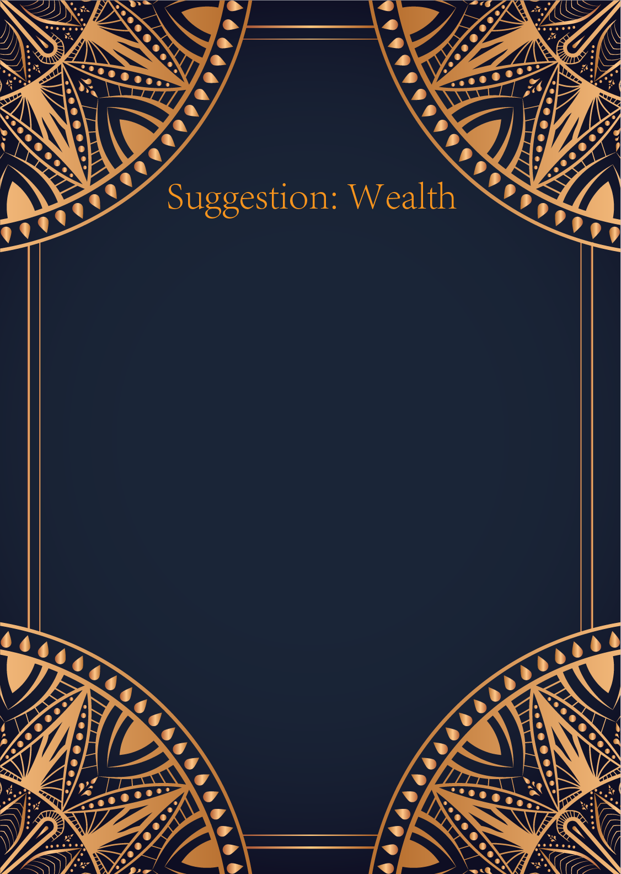

|  |
| --- |
| Ah, the Sun, the Moon, and the Star. An intriguing combination indeed. Let us delve into the realm of finance and see what guidance the cards have for you.   The Sun card shines brightly upon you, illuminating your path to financial success. It signifies abundance, joy, and prosperity in your financial endeavors. This card encourages you to embrace positivity and confidence in your financial decisions. Be bold and take the necessary steps to manifest your financial goals.   The Moon card, on the other hand, brings a message of intuition and mystery. It urges you to trust your instincts and explore the hidden aspects of your financial situation. Pay attention to your dreams and inner guidance; they may reveal important insights that will help you navigate any financial challenges that come your way.   The Star card offers a beacon of hope and inspiration in your financial journey. It represents optimism, renewal, and divine guidance. This card encourages you to believe in your own abilities and to have faith that the universe is supporting you in your financial pursuits. Stay true to your goals and aspirations, for success is within reach.   In summary, the Sun tells you to embrace abundance and confidence, the Moon urges you to trust your intuition and explore the unseen, and the Star reminds you to stay hopeful and inspired on your financial path. Remember to stay positive, trust your inner wisdom, and believe in the universe's divine guidance. Your financial abundance is waiting to be realized. |

